Mailing Address:

SADEKUL ISLAM

RESUME 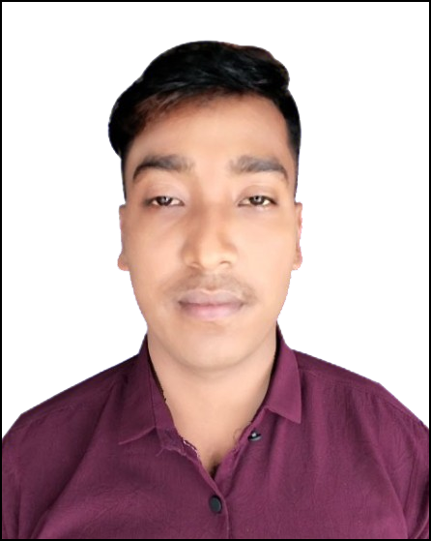OF

SADEKUL ISLAM

Nilphamari Sadar, Nilphamari

Contact No: 01788130820

E-mail: [sadekulislam8689@gmail.com](mailto:sadekulislam8689@gmail.com)

**Career Objective:** To work for an organization using my knowledge and experience based skills to the best of my ability to achieve best results and to add value to my post together with initiative ideas. My ultimate aim is to work as an active member of an energetic team in a large environment so that I can exploit my full potentials.

**Career Summary**: I am a professional Chinese translator with more than one year of work experience, mainly providing translation services for a Chinese wig company. I am responsible for translating the company’s product introductions, market analyses, customer feedbacks and other contents from Chinese to Bengali and English. I also have good communication and collaboration skills and can maintain good relationships with the company’s various departments and external partners.

## Special Qualification:

# Fluent in Chinese and English and can translate accurately and smoothly.

# Good professional attitude, can be polite, patient and friendly, respect the cultural differences.

## Experience:

### ​Chinese Interpreter (03 Months)

**Rongnil Hair Wig Processing Zone**

Company Location: Kanial Khata, Nilphamari .

### Duties/Responsibilities:

1. Worked as Chinese Interpreter.

### ​Line leader (March 27, 2022 - September 30, 2023) Million Gold **Hair Wig Processing Zone**

Company Location: Dorbes para , Itakhola ,Nilphamari

Department: Hand Tie

### Duties/Responsibilities:

### 1. Managing 40 workers .

### 2.Taking my caps targets from workers .

## Educational Qualification:

### Chinese Language H.S.K level 3

Name of Institution : Nilphamari Technical Training Centre

Group : Chinese Language

Result : Pass

Passing year : 2024

### Higher Secondary Certificate [H.S.C]

: Moshiur Rahman Degree College, Nilphamari.

|  |
| --- |
| Name of Institution |
| College. Board |
| Group |

: Dinajpur Education Board (DEB)

: Humanities

: GPA- 4.07 (Out of 5.00)

|  |
| --- |
| Result |
| Passing year |

: 2021

**Secondary School Certificate [S.S.C]**

|  |
| --- |
| Name of Institution |
| Board |
| Group |
| Result |
| Passing year |

## Computer Skill:

: Kanial Khata High School

: Dinajpur Education Board (DEB).

: Humanities

: GPA- 3.78 (Out of 5.00)

: 2019 ­

* Computer Knowledge (MS Word, MS Excel, Power Point, Internet Browsing).

# Language Proficiency:

Chinese: Chinese (hsk level 3) Score 266 .

* English: Proficiency in writing, reading, medium speaking & listening.
* Bengali: Proficiency in writing, reading, speaking &listening.

## Hobbies:

Playing, Cricket, Reading Book, Internet Browsing, Travelling etc.

# Personal Information:

Full Name : Sadekul Islam

Father’s Name : Barketullah

Mother’s Name : Mukta Begum

Date of Birth : 20/02/2004

Nationality : Bangladeshi

NID No. : 5565721619

Religion : Islam

Sex : Male

Marital Status : Unmarried.

Height : 5′5″

Weight : 60 kg

Blood Group : AB+ (Positive)

Permanent Address :Vill- Kanial Khata, Post- Kanial Khata,

P.S- Nilphamari Sadar, Dist.- Nilphamari.

Declaration

I hereby declare that all the resume’s furnished above are true, complete and correct to the best of my knowledge and belief.

Sadekul Islam